# Viewing Views - Explanation (view2)

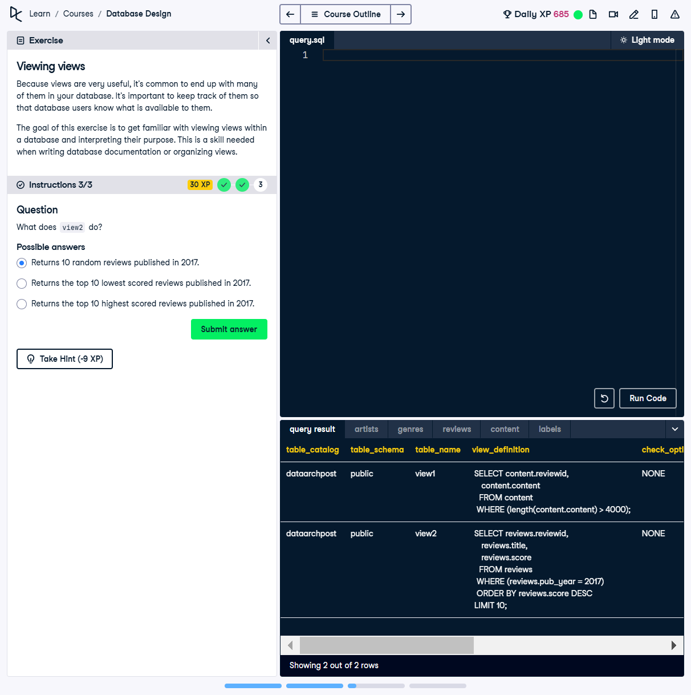

## Question

What does `view2` do?  
  
Possible answers:  
1️⃣ Returns 10 random reviews published in 2017.  
2️⃣ Returns the top 10 lowest scored reviews published in 2017.  
3️⃣ Returns the top 10 highest scored reviews published in 2017.

## ✅ Correct Answer

Returns the top 10 highest scored reviews published in 2017.

## Answer Explanation

🔹 The `view_definition` for `view2` is:  
```sql  
SELECT reviews.reviewid, reviews.title, reviews.score  
FROM reviews  
WHERE reviews.pub_year = 2017  
ORDER BY reviews.score DESC  
LIMIT 10;  
```  
🔹 This means that `view2` retrieves **the top 10 reviews** from 2017, ordered by their **highest score**.  
  
🔹 The **incorrect answers**:  
• The first option mentions `random` reviews, but the query **orders them by score**, not randomly.  
• The second option suggests the `lowest` scores, but `ORDER BY reviews.score DESC` sorts **highest to lowest**.